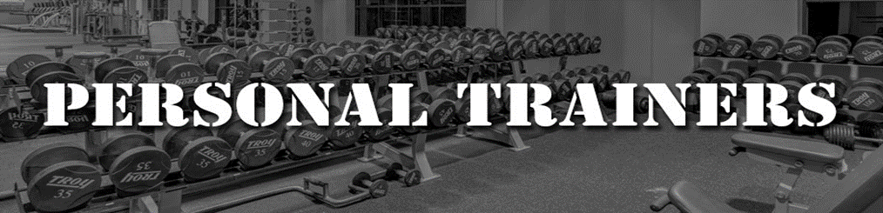
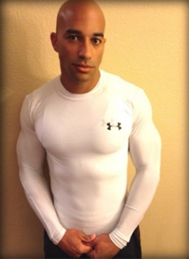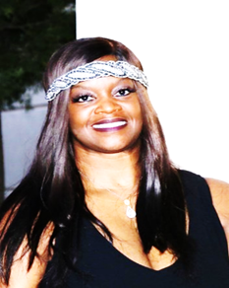
Anthony Yon Aretha Chandler
Certified Personal Trainer Certified Personal Trainer
Yon.anthony@yahoo.com madamuscle@yahoo.com
(707) 344-5789 (707) 365-0757
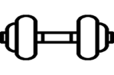
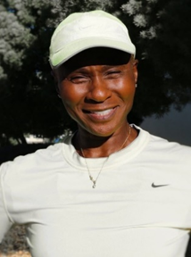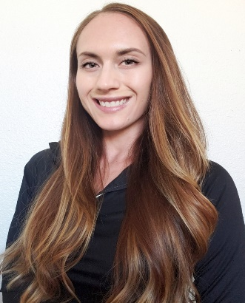
Yvette Gillard Christi Torrio
Certified Personal Trainer Certified Personal Trainer
yvette2024@gmail.com cetorio@gmail.com
(650) 346-4789 (520) 405-6254

